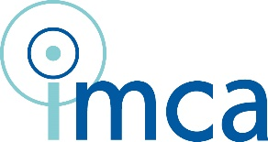

6, 7 July 2017, Dublin, Ireland

CMC-Global European Hub Meeting 2017

Registration Form

E: info@imca.ie F: +353 1 6650480
Attention: Tom Moriarty
Please fill out, and email or scan and send.

Name, Title

Institute

Consultancy Practice

Telephone, Email

Any specific dietary need or wishes?

Payment:
Bank transfer after receiving the invoice with bank details

Date / Signature

Name of accompanying partner (if applicable)

